Experiment 5(a): Simulation and Performance Evaluation of RFID/NFC-Based Device Identification and IoE Data Integration using Node-RED and MQTT
Objectives
- To simulate RFID/NFC-based device identification using Node-RED.
- To transmit device IDs using MQTT.
- To process and validate device data using Node-RED.
- To visualize device information on a dashboard.
Software Required
- Node-RED
- MQTT broker (Mosquitto or Node-RED MQTT nodes)
- Node-RED Dashboard
Procedure
- Open Node-RED and create a new flow.
- Configure an Inject node to simulate RFID/NFC tag IDs.
- Connect a Function node to process device IDs and generate sample sensor data.
- Configure an MQTT Output node to publish data to ioe/device/id.
- Use an MQTT Input node to receive the published messages.
- Connect Debug nodes to verify the received data.
- Display device IDs and sensor readings on the Node-RED dashboard.

Output:
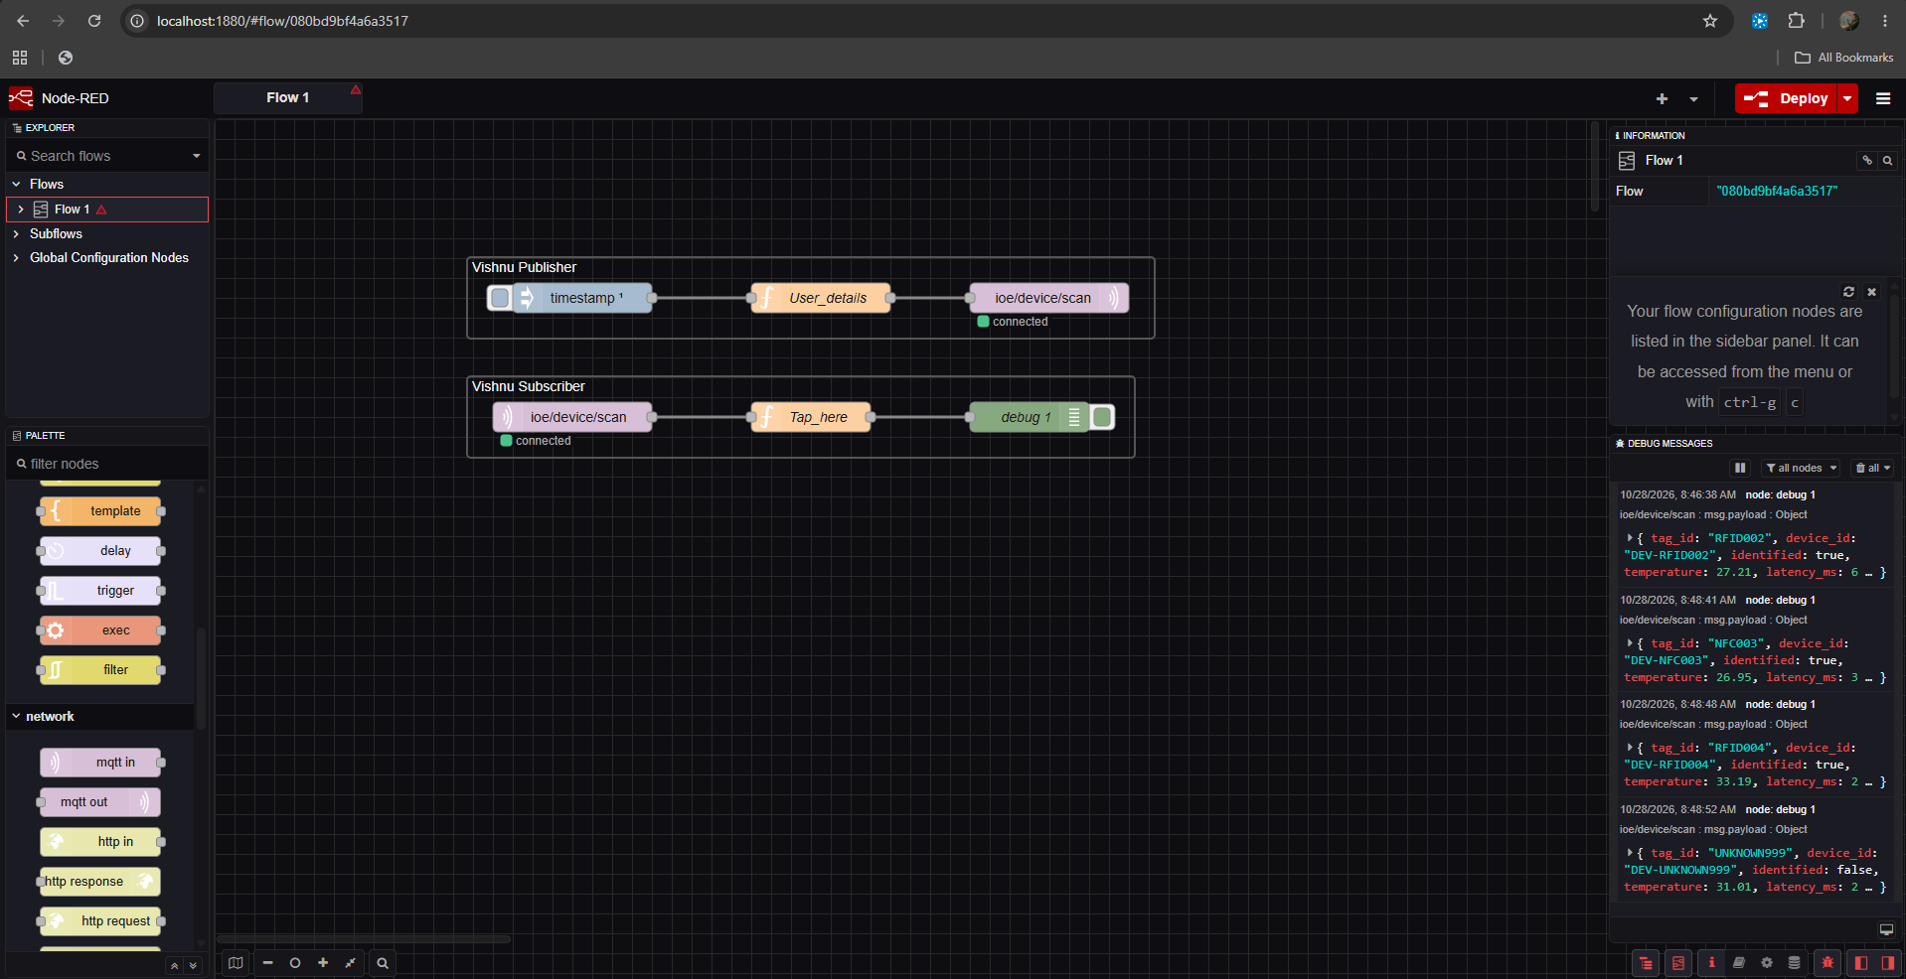

Output Table
S.No. | Parameter | Expected Output
1 | Device ID | Valid simulated ID
2 | MQTT topic | ioe/device/id
3 | Message transmission | Successful
4 | Data processing | Valid device data
5 | Dashboard | Device details displayed

Result
RFID/NFC-based device identification and IoE data integration were simulated successfully using Node-RED and MQTT.

